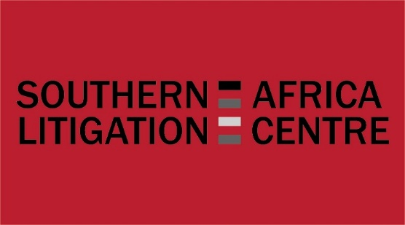

FREEDOM OF EXPRESSION LITIGATION WORKSHOP
JOHANNESBURG
16 – 18 SEPTEMBER 2015

APPLICATION FORM

Name

Organisation

Address

Contact numbers

Email address

Please return your completed application form with your case summary/ summaries and relevant case documents by Friday 31 July 2015 to:

Caroline James
Southern Africa Litigation Centre
E-mail : carolinej@salc.org.za

Please note telephone interviews may take place on 11 August 2015.

(Throughout this application, please feel free to expand the boxes to fit your answer)

1. EXPERIENCE:
Please indicate your relevant experience in the following areas, giving examples as appropriate.
a) Briefly outline your litigation/advocacy experience:

b) Describe your experience that best demonstrates your interest in and/or knowledge of the right to freedom of expression:

c) Describe your experience that best demonstrates your knowledge of international or regional human rights law:

2. CASE DESCRIPTION
a) Name of case:

b) Describe the facts and/or circumstances on which the case is based:

c) Describe the nature of the legal problem; including the rights violated, the relevant themes and the law/policy being relied on:

d) Is the case before national courts or international fora?

e) At what stage is the case – pick one:

- violations identified and litigation considered/planned
- proceedings instituted
- awaiting judgment
- on appeal
- domestic remedies exhausted
- seizure
- admissibility

f) Any other relevant information:

Note: Please include copies of relevant documents (e.g. pleadings, complaint, indictment, court judgment) that are related to the case.

Note: When submitting more than one case for discussion, please copy and paste the boxes under “Case Description” above as appropriate.

